Date: 22-july , 2026 , 07/22
C is optimized
But neural network me python jeet jayega , kyuki vaha pr bahut bade bade matrix hoga.

Gnuplot chalaya points plot kre, then ek line plot kri , bina line hate usi pr ek or line plot krna
Phir ek line hata di and line ko clear kr k

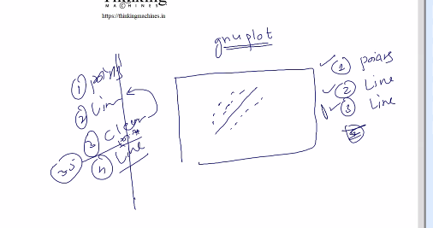
Scaling: ka
Sb ko 0 se 1 k bich me le aao

Date : july 29 07/29
Last session ka assignement : line animated form me design krna he.
Issue: code to khtam ho gaya but gnuplot ka kaam chl rha he. Popen wali technique se krna he.
humne jo example implement kiya usme error minimize krne k liye jo use kiya usko gradient descent bolte he. 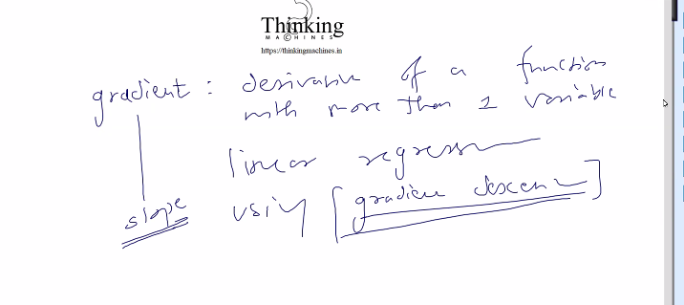
Issue: Agar huge dataset hua to kya hoga.
Process slow hogi. Matrix multiplication dikkat de jayeg.
Humne tarika kya apnaya.
All training example: process start kri , cost compute kri , weight update kiya to usko batch gradient descent bolte he

Stockastic gradient descent
1 training example picked at random , cost compute kri, weight update kiya , phir dursa training update kiya and so on , and har cycle pr weight update kiya
Ese 1000 examples k liye kiya ,
Ye sb andr k loop me chl raha he , vo outer jo he iteration wala vo to alag he
Outer wale k ek iteration me iske 1000 chle esa bol skte he

dono k bich ka : mini batch gradient descent
How: 1000 me se 100 liye ek batch
Ese kr k ek iteration me ye 10 baar chlega.
Humne jo function likha he uska naam change kr k batch_gradient_descent krna pdega

Kese kre?
Abhi tk matrix aaa raha the but ab to matrix bahut bada he ,unloadeable he and y vector bhi nahi aa skte.
Is case me x vector hoga, y and yhat scalar hoga , coz 1 hi row aa rahi he.
Usi k liye krna he.
Fuction ko data_provider pass krege, ye ek function hoga and iska address fit() ko diya jayega.
Data provider kaha se lekr aa raha he ye fit() ko is se koi mtlb nahi.
Data provider ka count outer loop initialize krega and inner loop me data provider ko call kiya jayega. And bola jayega ki mere ko ek row do ek y do ,
Jo de chuke he vo vapis mt dena , ye headache fit() ka nahi ye data_provider() ka rahega.
Usko to serve krna he ek ek kr ke.
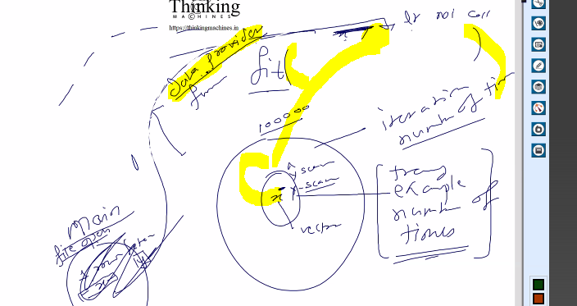

Ab hard diks 1 gb ki ,,, dataset file 200 gb ki, ram 8gb ki
Usme fopen() se read krne k liye open kiya to open hogi ki nahi
Ans: hogi kyuki file chunk me read krti he , pura ek sath read nahi krti he.
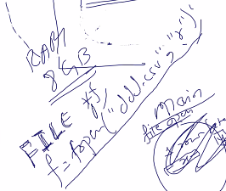
e.g. 100 gb ki video hoti and ram 4 gb phir bi play krta he, kyuki , buffer me read krta he.

Same word k case me , humko esa lgta he ki puri file ek sath open kr di par nahi , vo onscroll page ko naye data se redrarw krta he.
So this is the concept of reading large file.
ML k aaspas ki duniya bnane me time lgata he , actual implementation to thodi si line ka kaam he,
Ye

Iterator: koi bhi chiz shuru se shuru na kre.
Data provider ko or behtar bna le, 100 100 lekr rkh skte he.

Structure: isko bdi baat kre to token
Starting me null dega, then structure return krega jo data provider usko dega.
Ye uske sath chedchad nahi krega only dataprovider hi uske sath chedchad kr skta he
Bich me light chli gai to phir se 1 se start krega, but light nahi gayi to structure k basis pr usi point se chlega.
And file open hi rahegi.
e.g.
main() wala dataprovider ko call krega and (1,null) bole ek record de do ,
data provider() file open kr k first row return krega and \n tk read kr k
and then agle r
ow k first byte pr pointer rahega.
And ye us main ko vo structure dega,
Vo main isko process krega matrix mult and all.
Iski process hone k baad agli row mangega (1,struct).
Dataset load krne ka kaam data_provider() kr raha he.
Bich me light chali gai to phir se 1,null se strt hoga, coz hard disk pr to final model hi save krna he.
And vo to outer loop pura complete hone k baad hi likha jayega.

Date: july 31 , 07/31

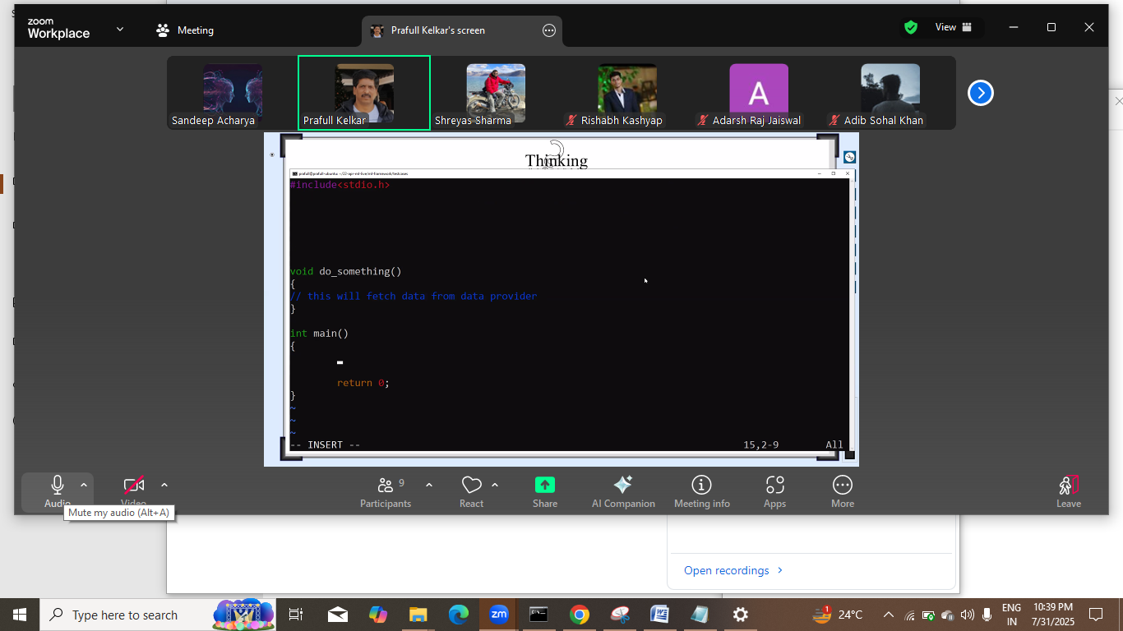

Date 31-july , 7/31
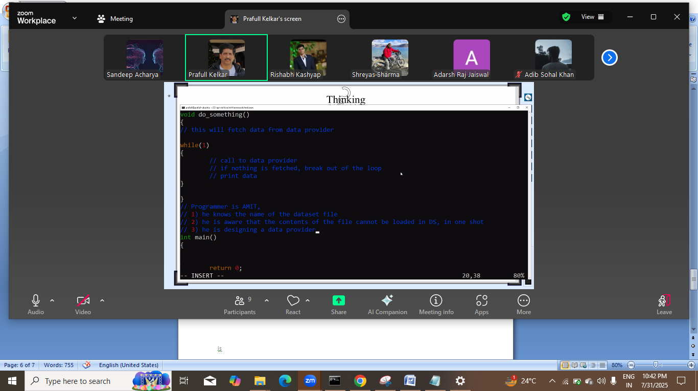
Structure, file, and function jjis se dosomething baat krega.
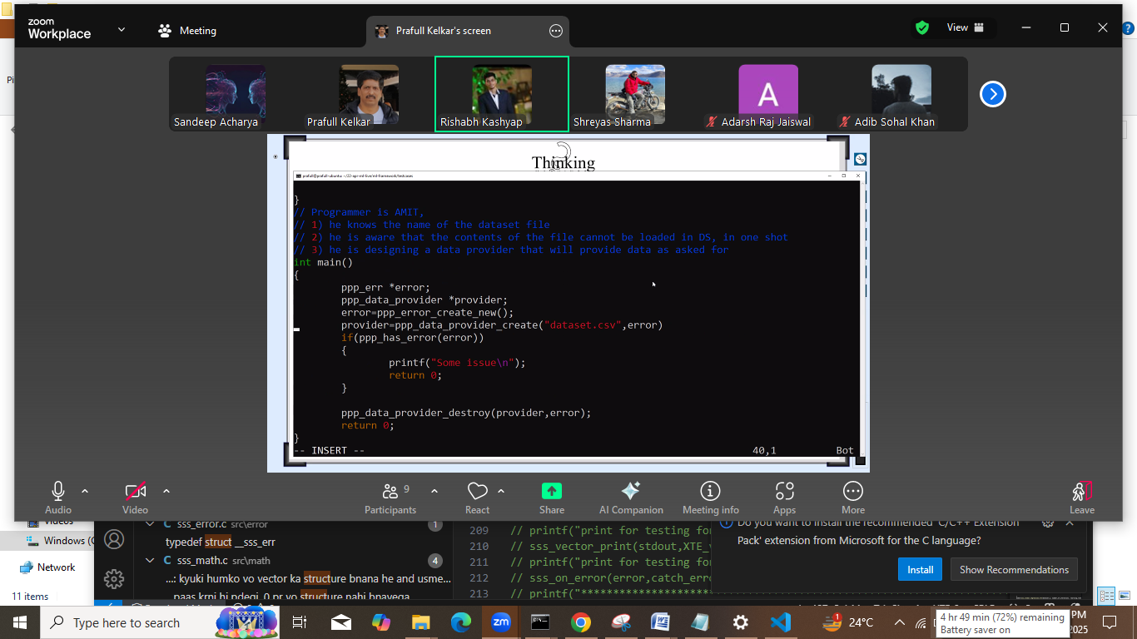
Yeha provider bna to file khuli hna chahiye ya nahi.
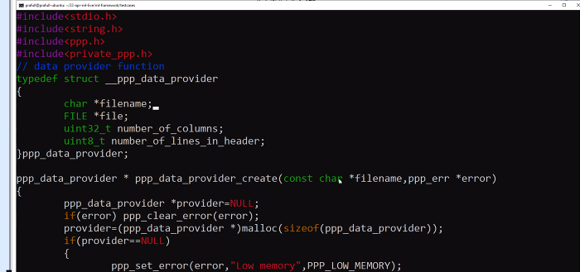

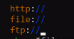
Provider function http se ya file se ya resource url se, abhi hum file se lekr krne wali programming
C ka koi function ,: jo bta de ki file exist krti he ya nahi.
Actual projects me read permissions ki baat bhi aati he.
Humara function change kega uske liye ye procider structure.
But vo data_provider() kon bnayega?
Ans: framework use krne wala.
Generic k liye file * ko void * and filename ko resource:
SS
Main likhne wala function bnayega and uska pta de dega to struct me ek or member rkkhte he jo us function ka address hold krege
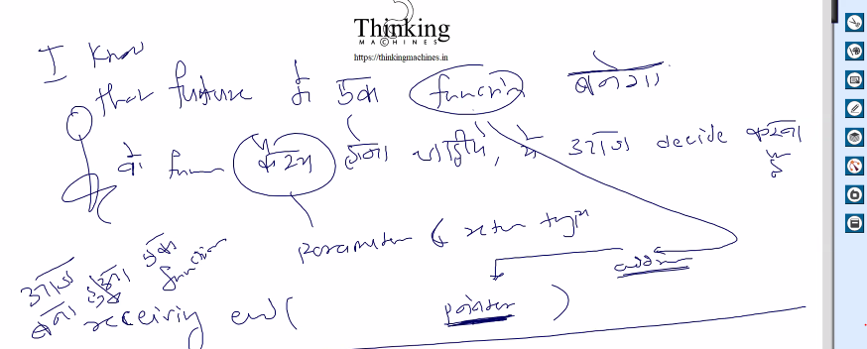
Kalu ko chahiye ki kaha se kya pdna he uske liye structure bnaya , and kalu ko ye structure diya.
Hum cs
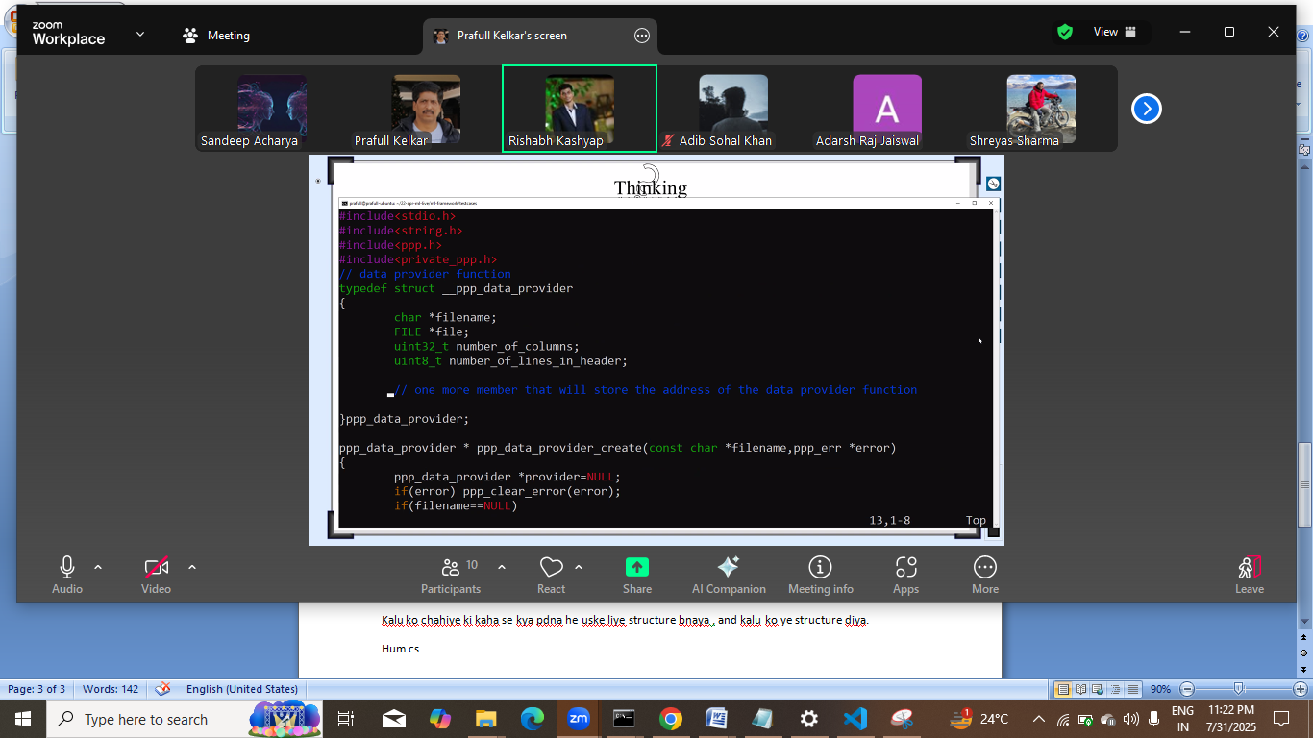
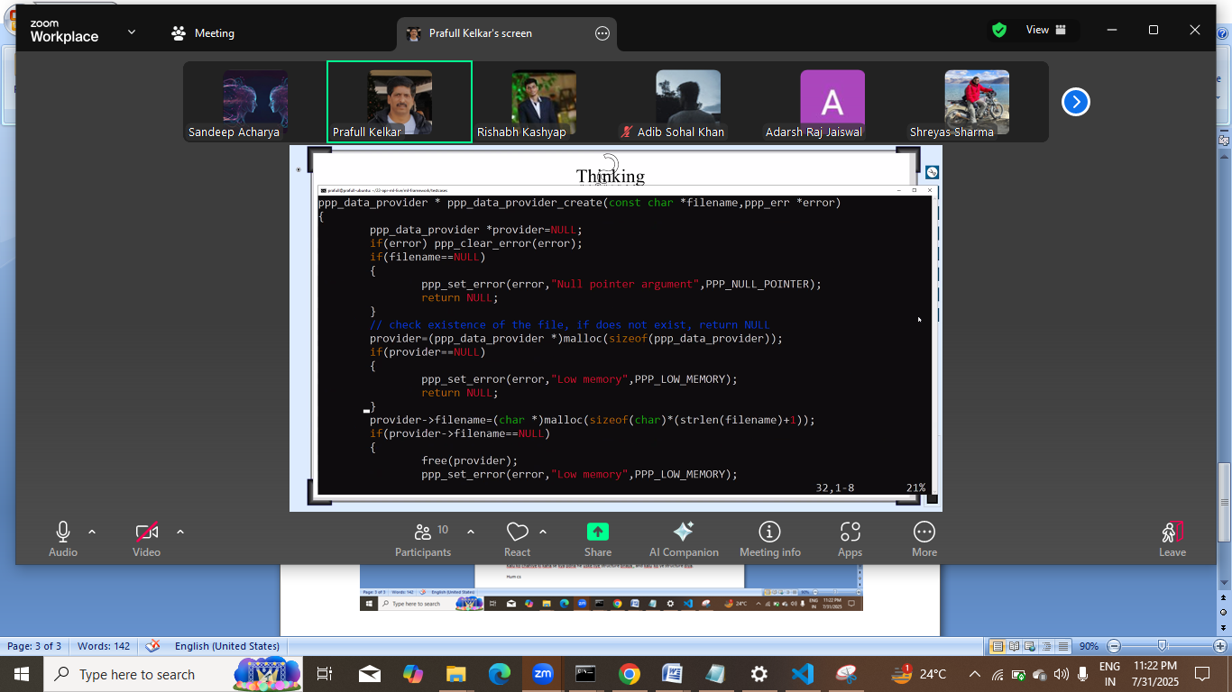
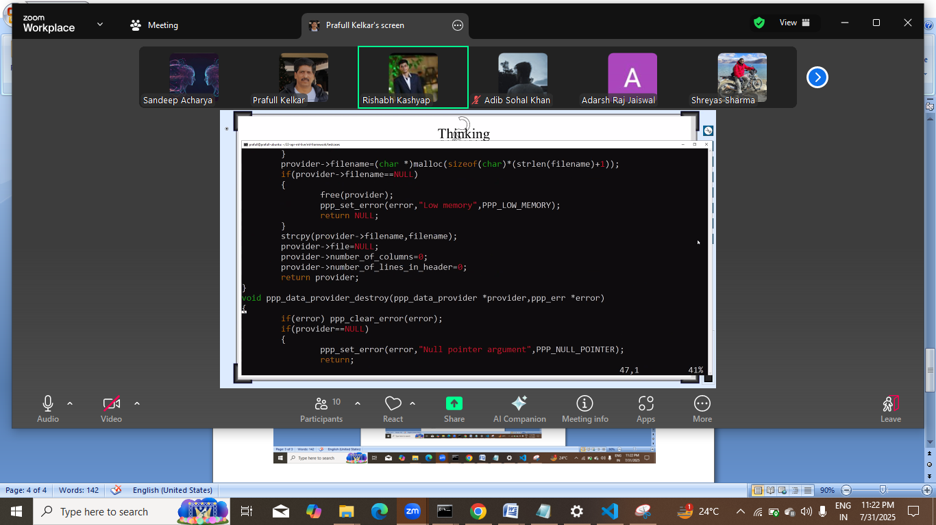
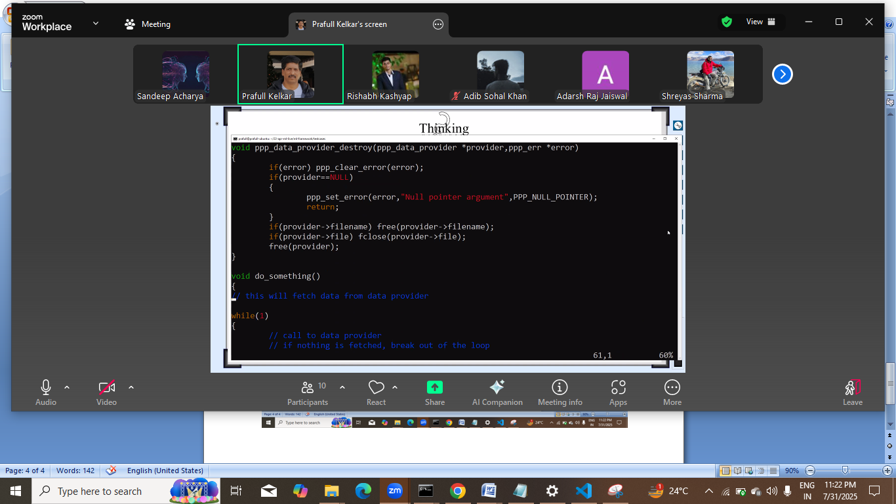

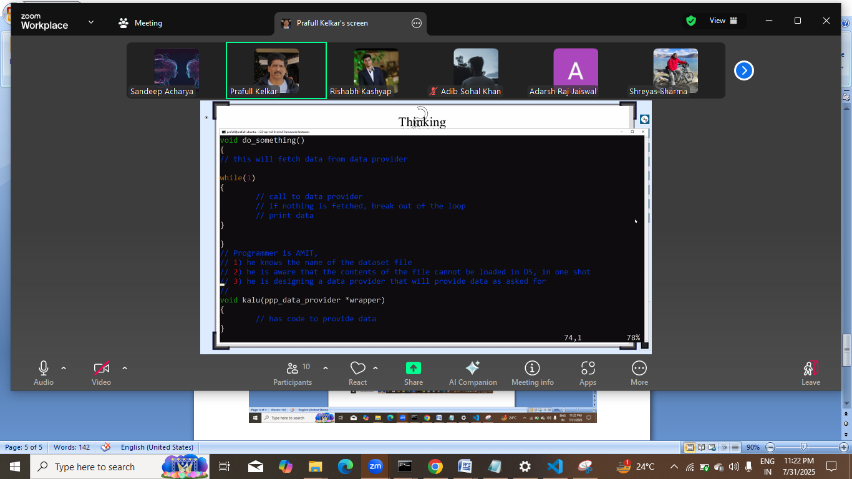
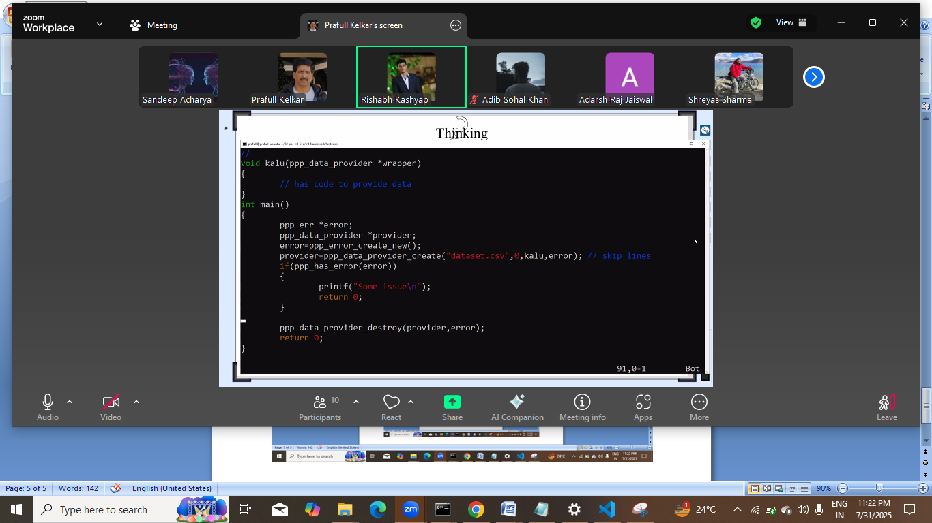
Machine learn , 5 din , 50 din duniya bhar k kaam
Next: 5 din and then 15 din paper work.
Abhi humara model vector form me he,
Aage neural net me matrix k roop me hoga and vo bhi multiple matrix
To un sbka partial derivatve?
Bahut lambi process and paper work .
And esi chize net pr nahi milti and original source code se bhi nahi pta chlta.
4 line ka code and dher saare function call
To us sb ko dekh k derive krna bahut mushkil hota he.

Date : August 7 , 08/07
Pointer to function jiska parameter sss_data_provider ka pointere and return type int

Isme kalu ka address paas kr skte he
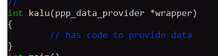
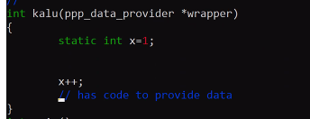
Static se one copy of kalu shared between multiple copy of kalu
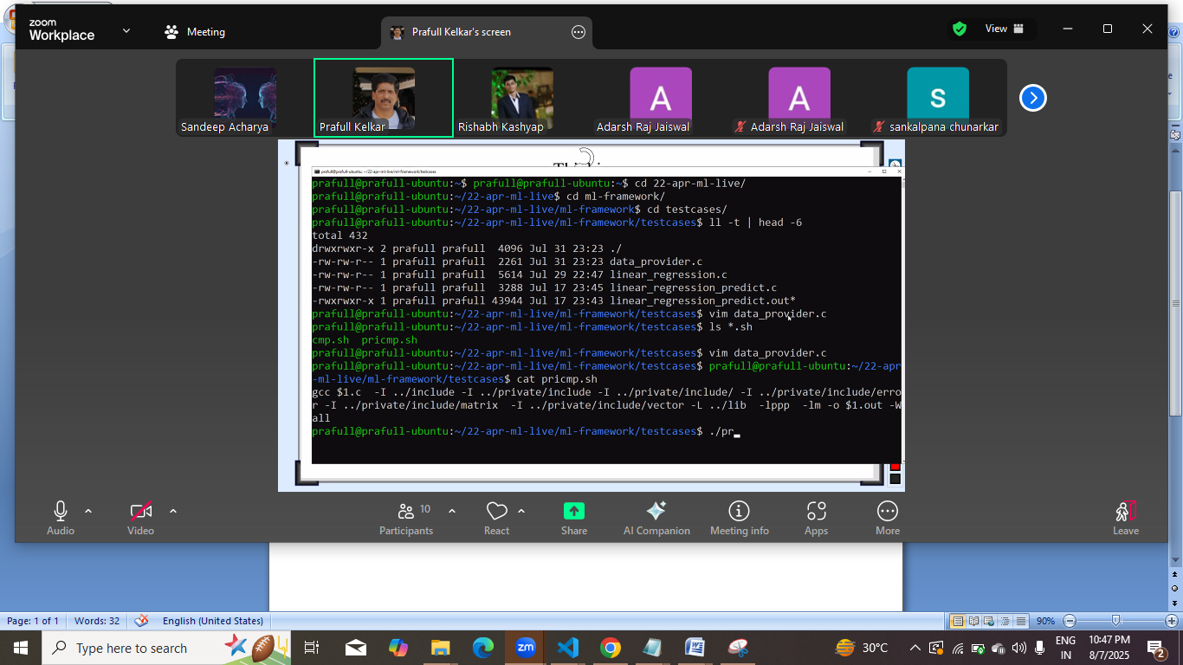

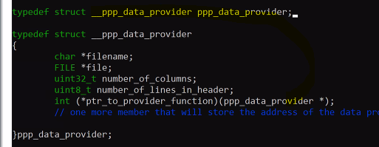
Isko define se phle use kr rhe the to declare kr diya taki code compile ho jaye.

SS:
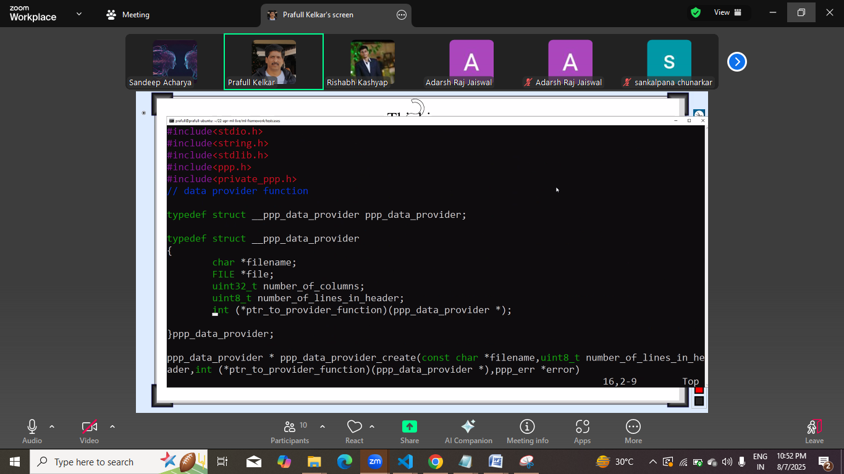
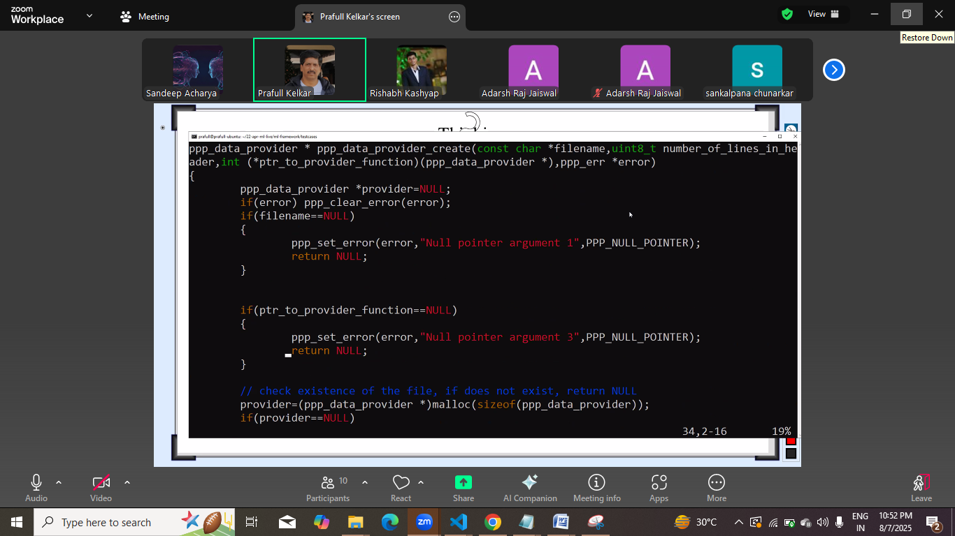
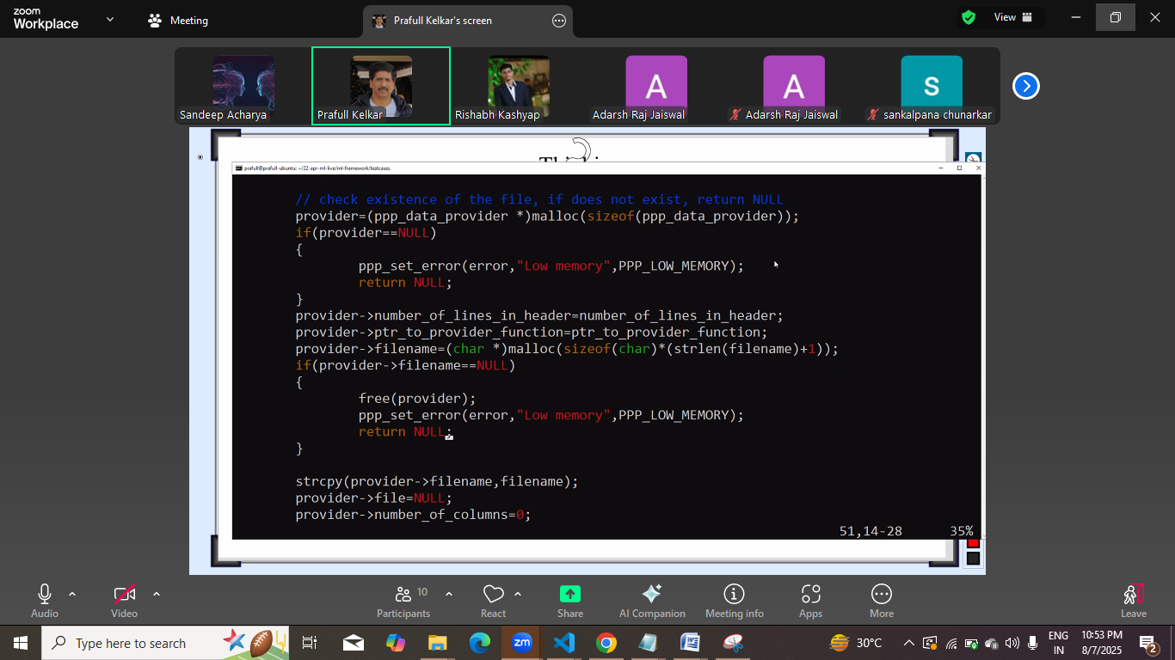
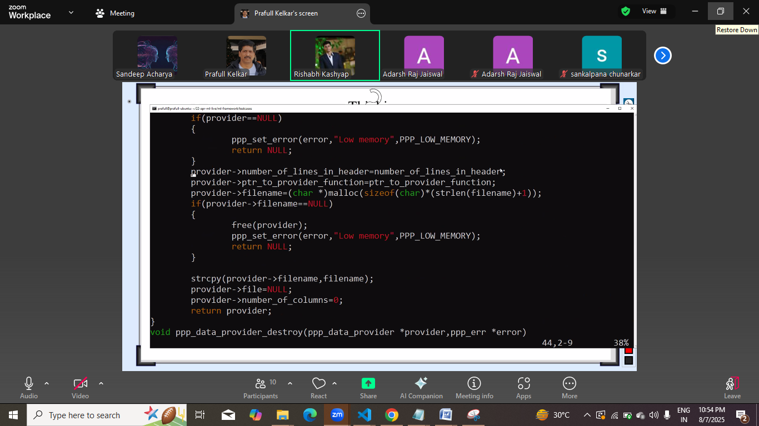
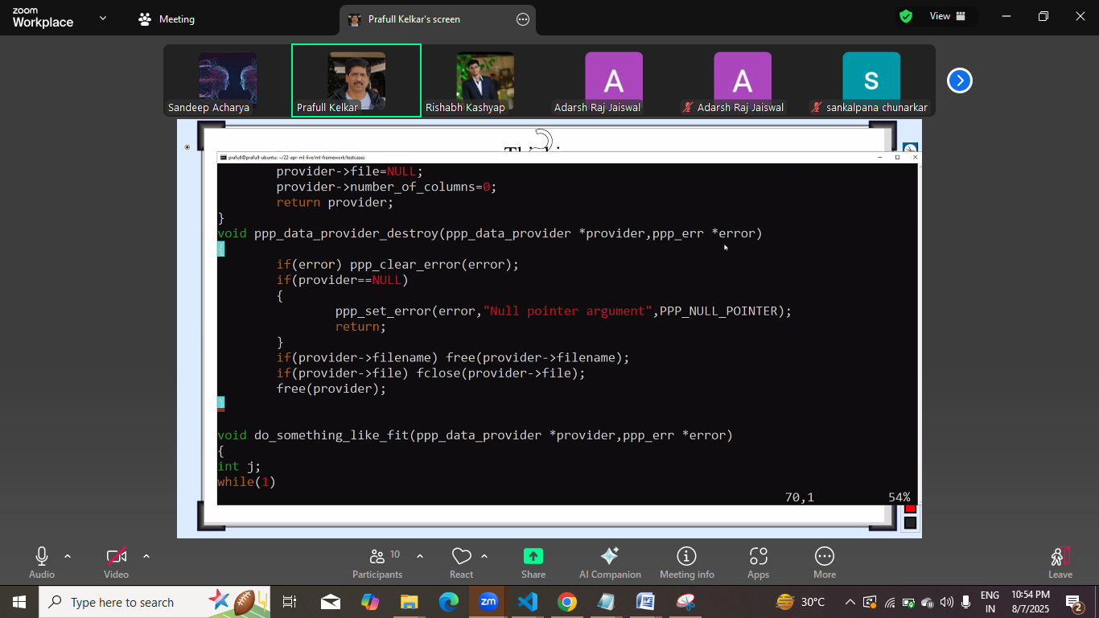
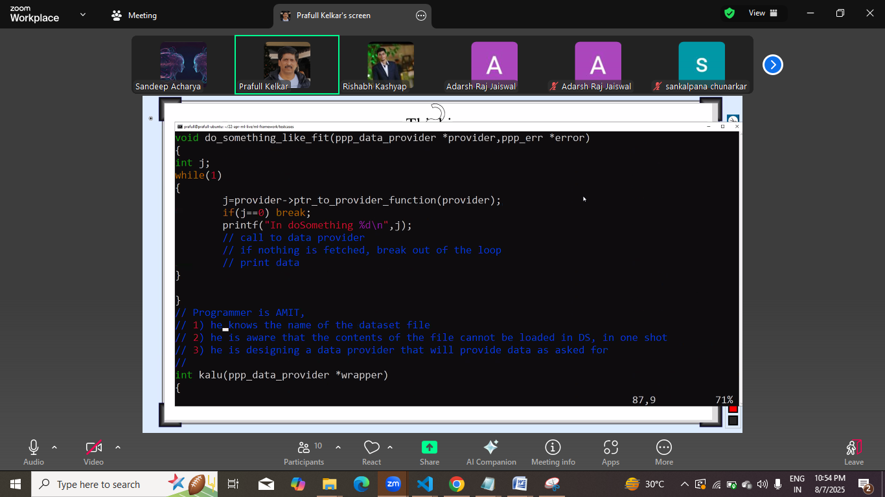
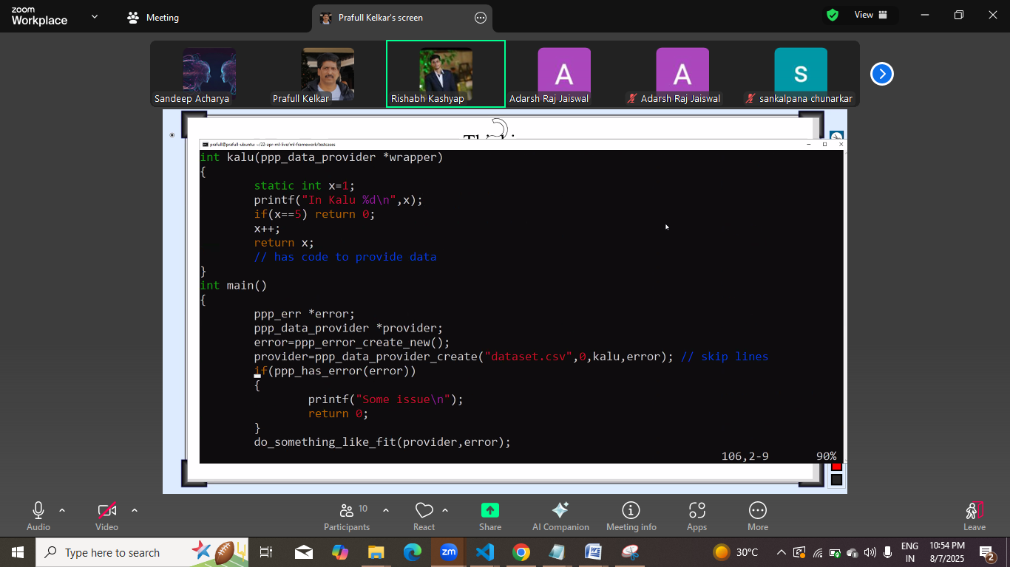
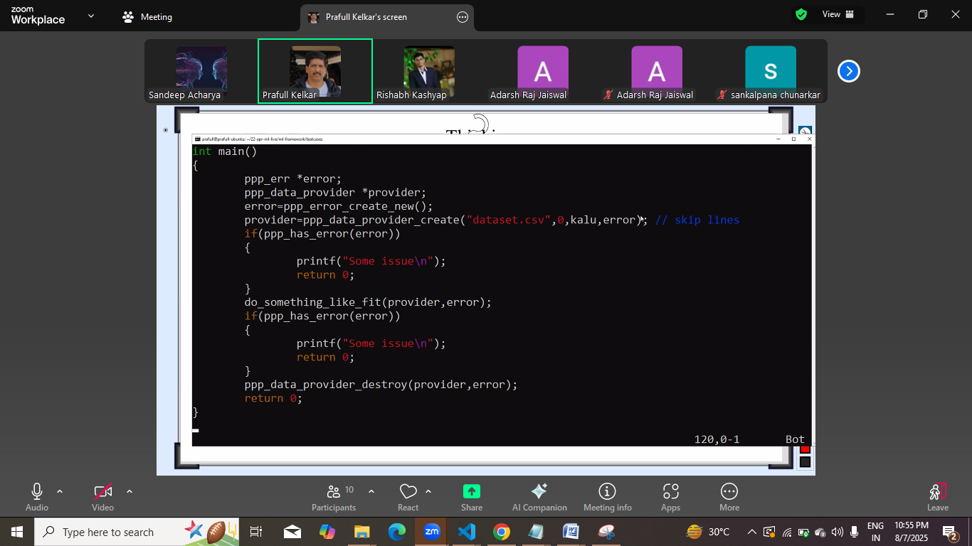

Next:
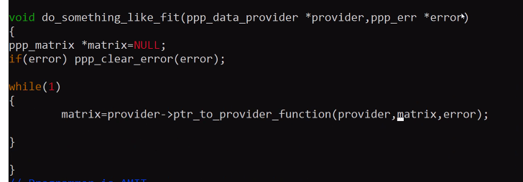
Ptrtoproviderfunction id memberof provider that holds address of kalu()
Matrix ko first time null kalu k paas null gaya , kalu k paas data he and usne matrix create kiya and uska address return kiya to ab humare matrix me vo address aa gaya, agle cycle me vahi matrix ka add kalu ko diya kalu is baar naya create nahi krega and usko container man k usko bhar dega.
Esa 5 baar hua and kalu k paaas data nahi he to vo is baar null return krega.
Ab matrix ko freee krne kaa kam to nahi hua kyuki kalu ne bhi nai kiya free and humare paas bhi nul he
Ab usko free kon kare?
Kalu() ya dosomething();
Note: abhi 2nd baar bhi kalu ko null diya to dusra bnayega.
First baar me 1000, 2nd baar matrix ki kagah null to usne naya bna he 2000.
Abhi demand kon decide kre?
Kalu ya dosomething_like_fit()
dosomething_like_fit() , issue , utne available nahi he to kalu nahi dega.
To marix bnake do
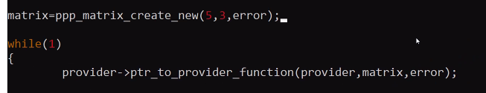
Abhi row to humko pta he but column kitne he file me ye gyan to provider ko hi he , and jb pta chlega jb vo file open krega tb.
To yaha ye scne fail ho gaya.
Row to hum bta skte he but file me column kitne.
Isko kese pta.

Vo jisko free krna he usko store kr skte he , but jb null paas krege to har baar vo naya bnata jayega.

To matrix bnane ka kaam kalu nai de usko onl =y container de but column size kaha se pta kre?
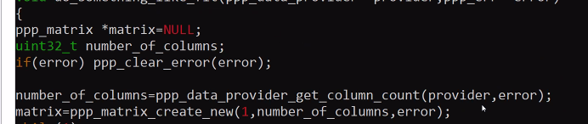
To provider se pta kre lege.
Ab file khulne ka kaam kakha>=?
Getcolumncount() method k andr
But esa kr diya
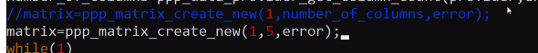
Humne khud hi 5 column pas kr diya to issue agar 5 column nahi hue to kalu error return krega
To is case me error message alag hoga
And no more data k case me alag hoga
Ye sb dhyan kalu ko rkhna pdega
And framework bnane wala file kholega
And usko vahi bnd kr dege and

Baad me phir kholege
Is se pointerto function me change aayeaga
And bhi hum likh rahe to vo change kalu() me aayega.
Kalu k signature se kalu likhne wale ko pta chl jana chahiye ki usko kya serve krna he,

Phle ka compile hone k baad k change
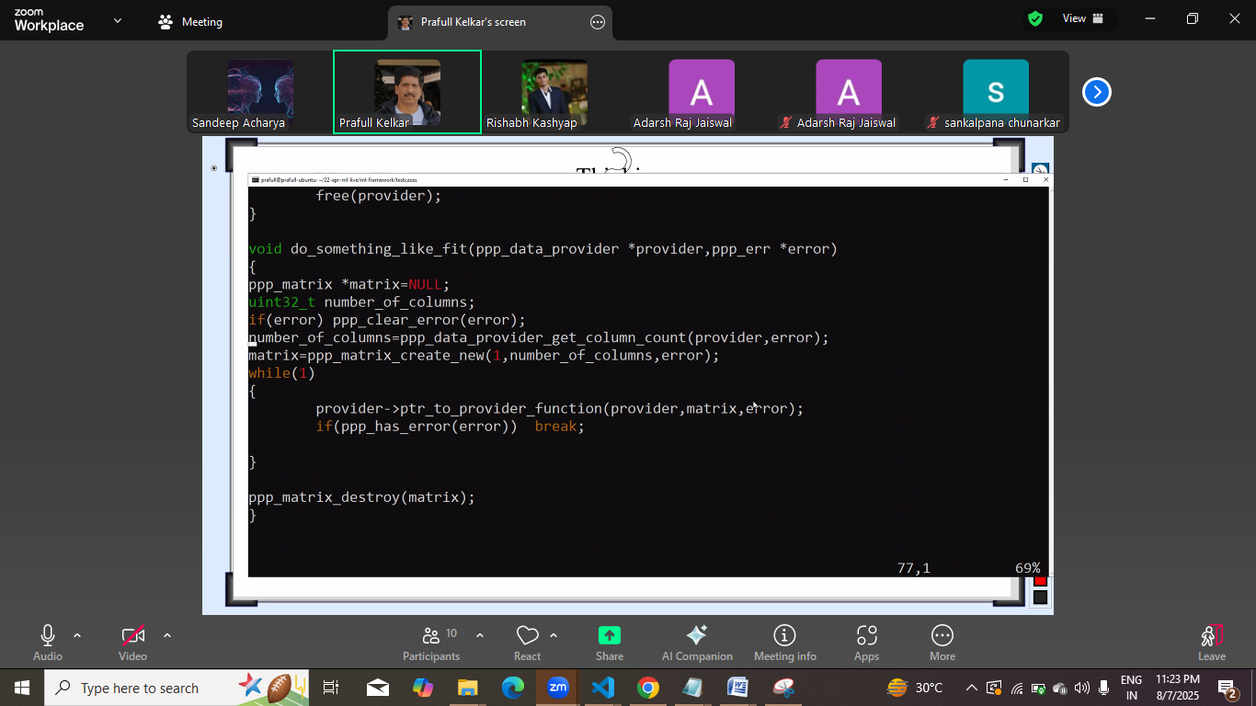

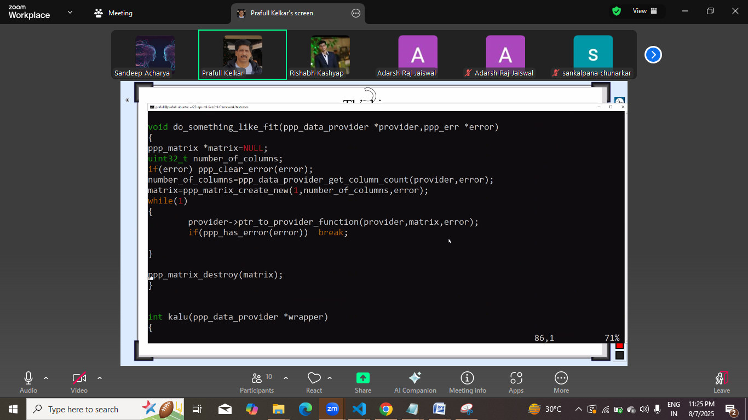

Show off:
No login no payement no signin , open to all
User aayega, and dataset upload krega but huge dataset load kr diya.
Cloud provider ki billing bahut saaari he.

Date august 12, 8/12/2025
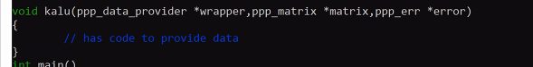
Yaha pr kya solution:
Saamne wale ko gyan dena pdega,
Ya to return type ye rkhe ki kina bhar k de rahe he
Ya ek parameter bda de, usme kina bhar k de rahe he uski jankari de

Ek pointer bdega and in function me change hoga
Kalu()
Create ()
And pointerto function() declaration me
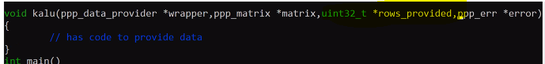
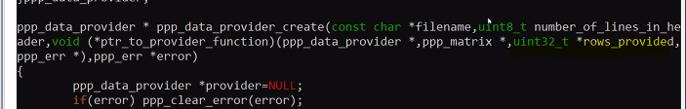

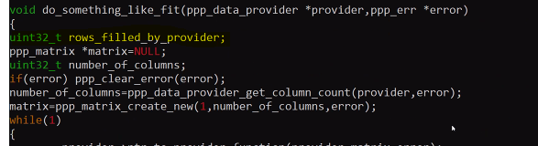

Ab kalu likha ja skta he:
File open nai he to file open krna he, and column gin lege agar gine nahi he to
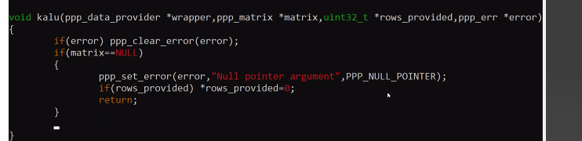
Rows provided means phle file open nahi hui he.
Hui hoti to isme kuch na kuch hota.
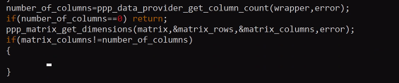
Ab yaha pr jitney column diye utne me bhar de ya error de de.

Abhi iske baad matrix populate
Ab mini batch gradient bnana he , stokastics k

SS
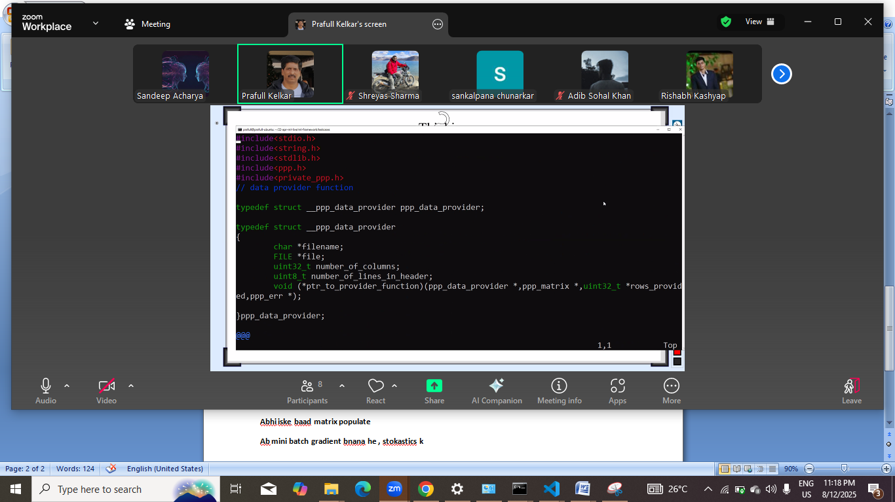
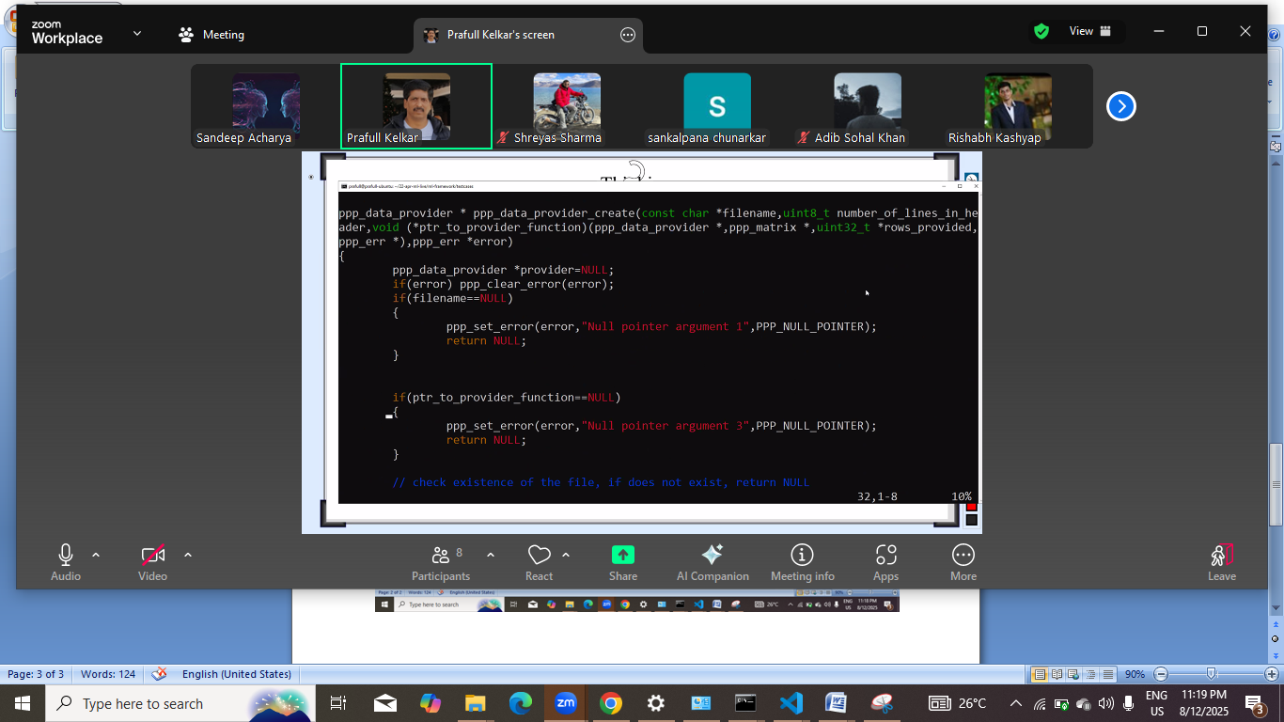
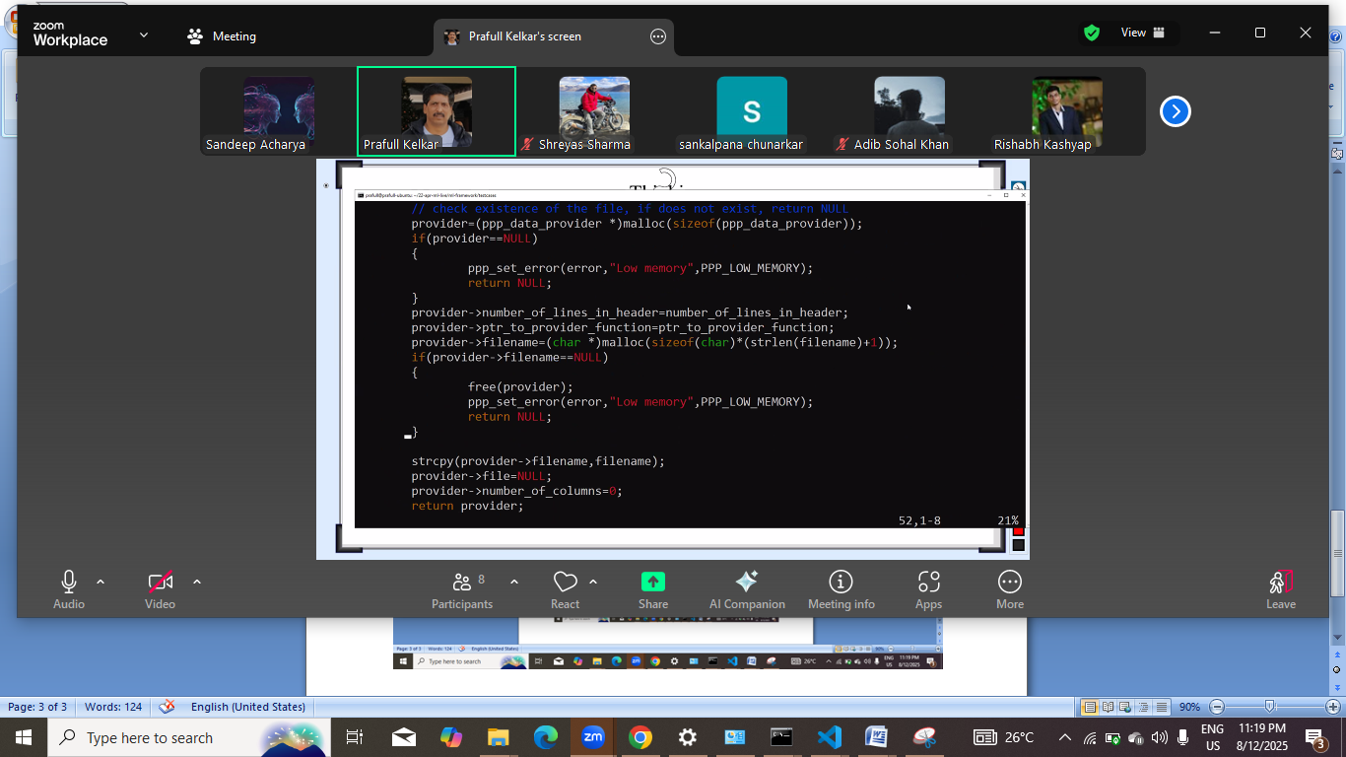
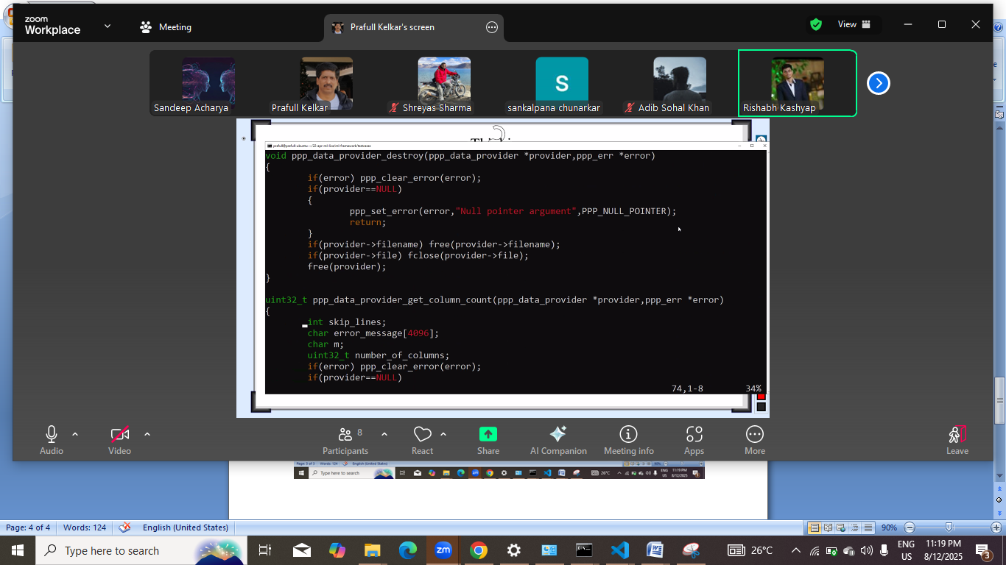
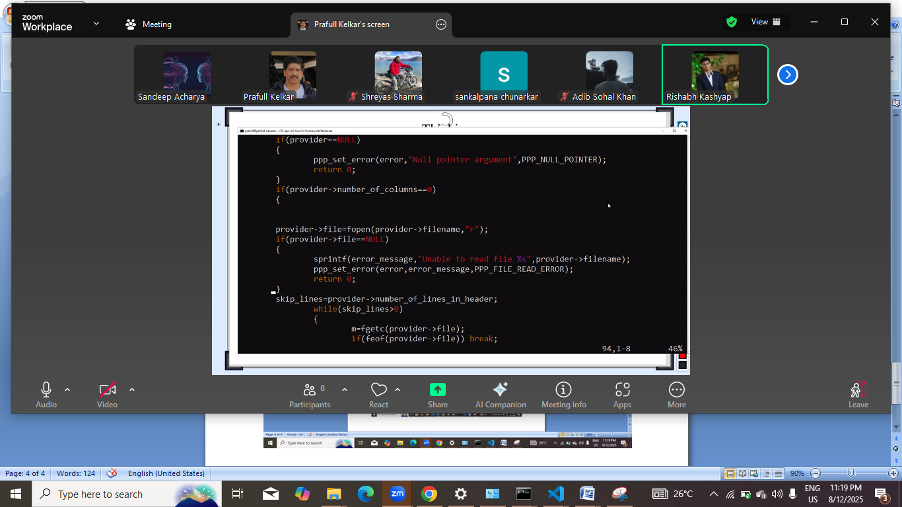
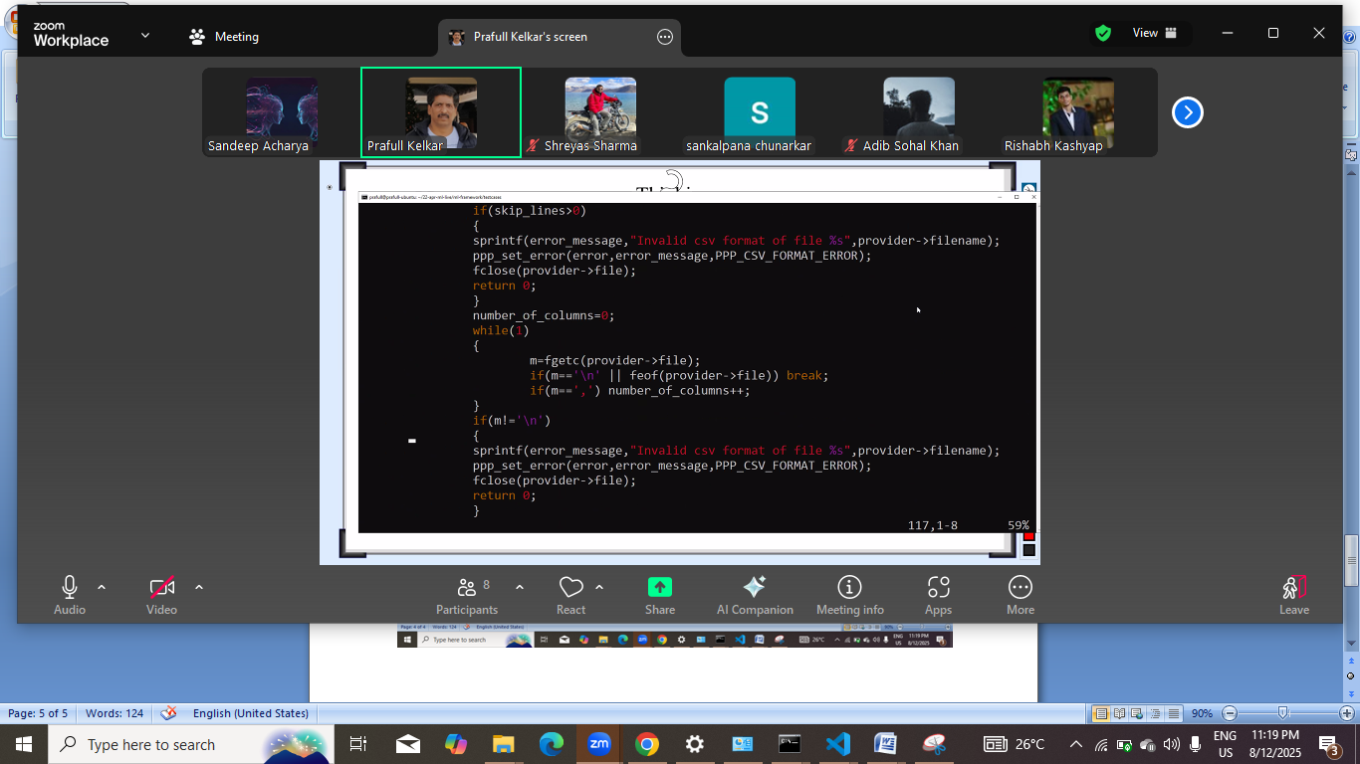
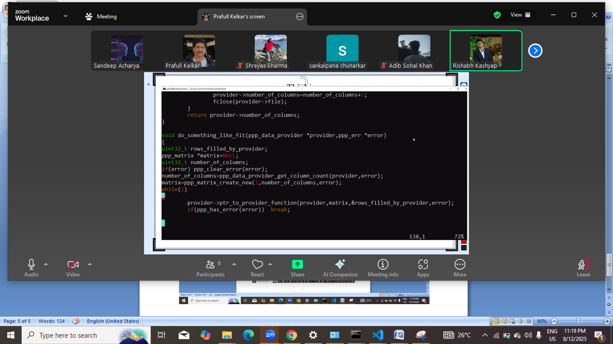
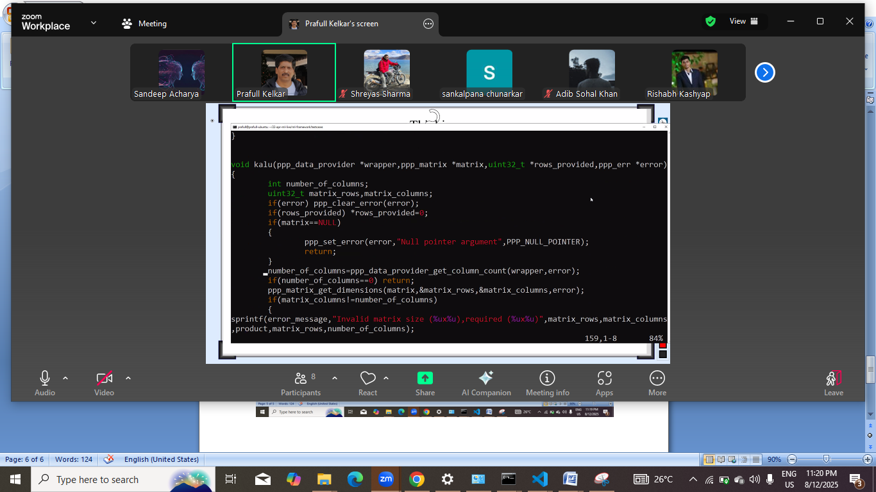
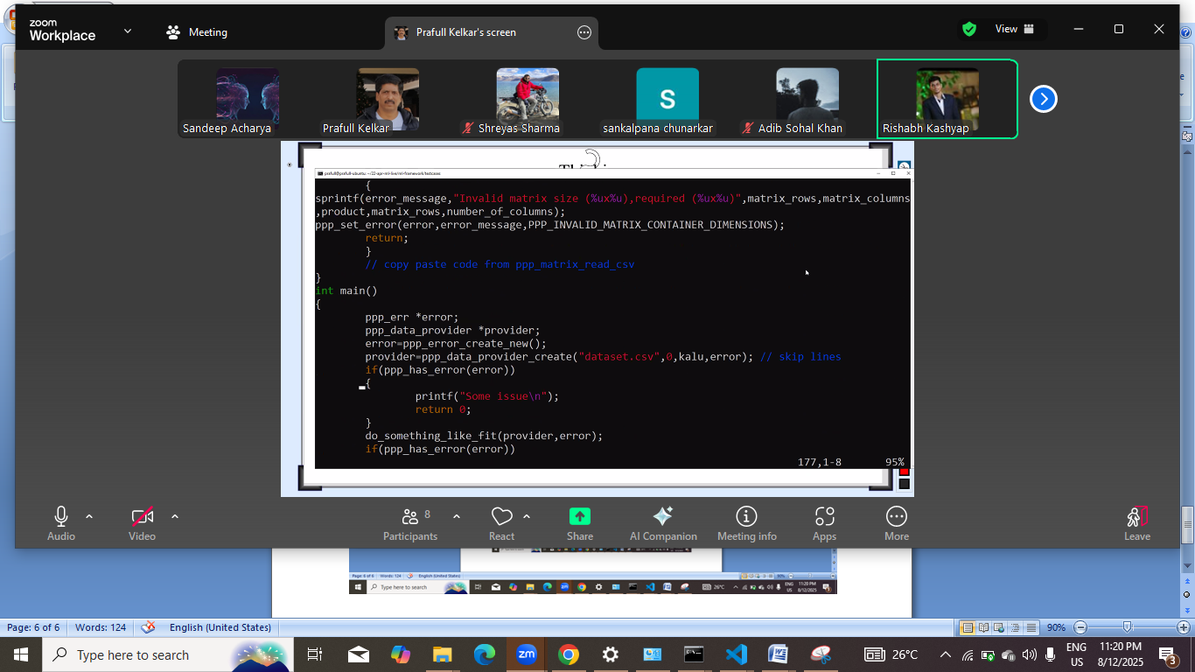
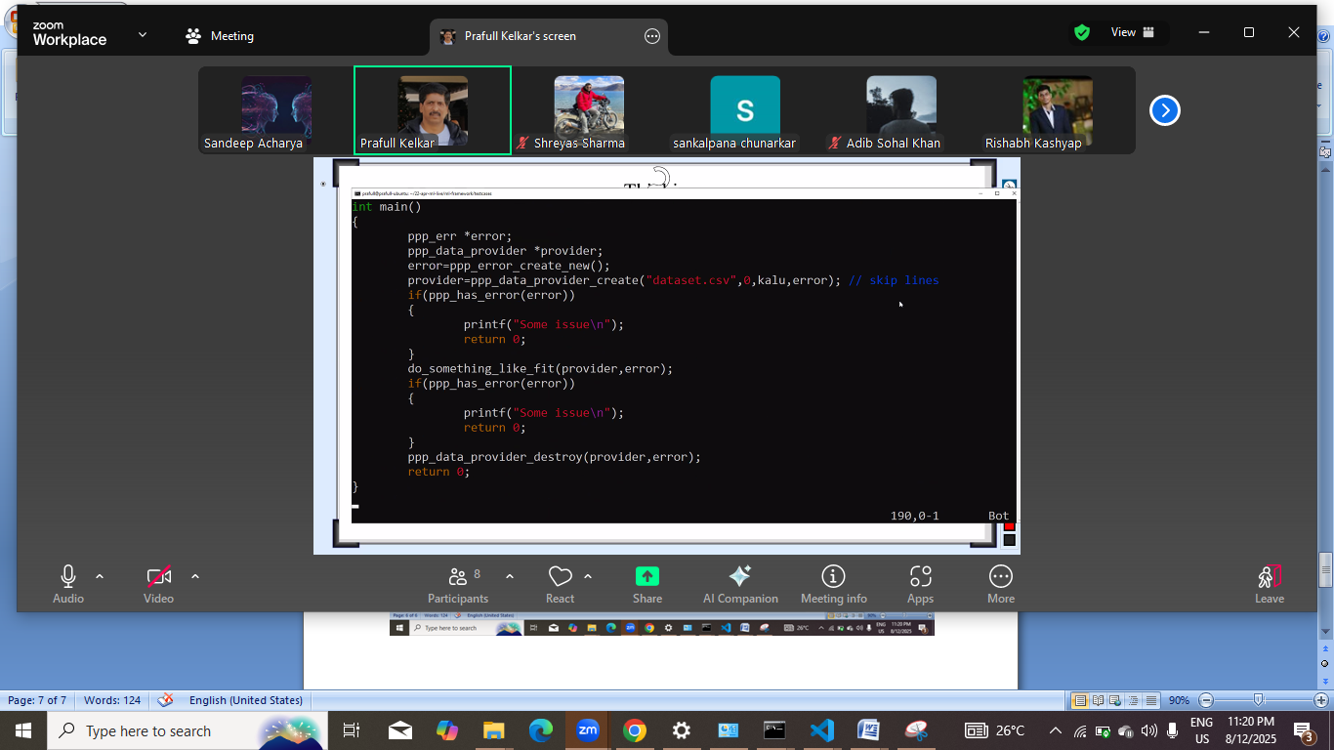

Date: 16 august , 8/16

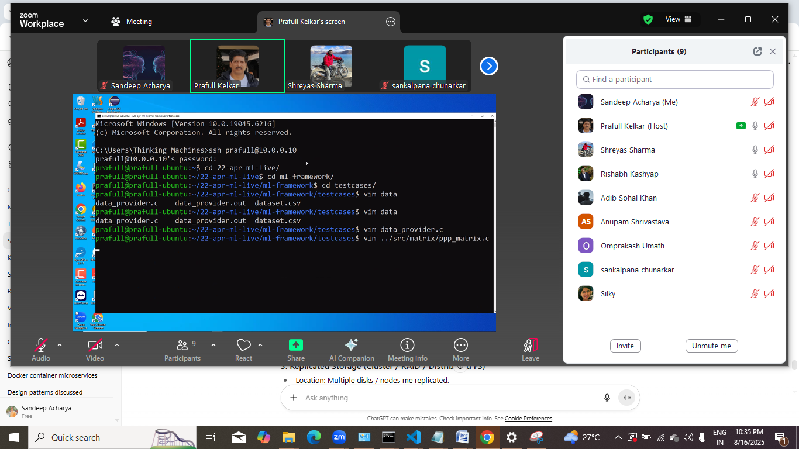
Ajj ka ss
Vo dumb wali error recreate krna he , kuch file ko null nahi kr k provider ko free nahi kiya tha kakhi.
Linear regresssionki cooy,
Isme se something like fir hatega
Final
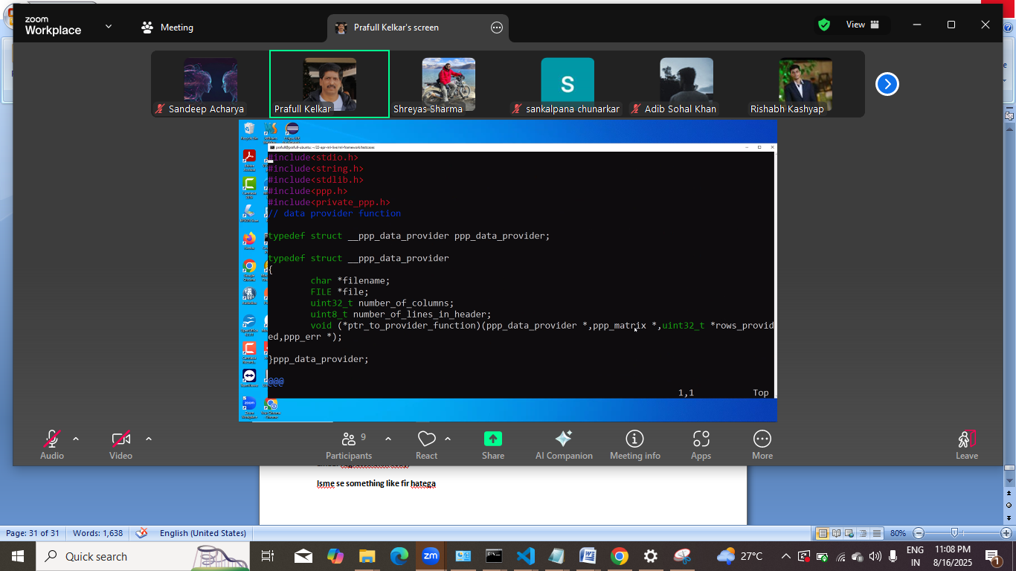
Graph dekhege to crukuid line
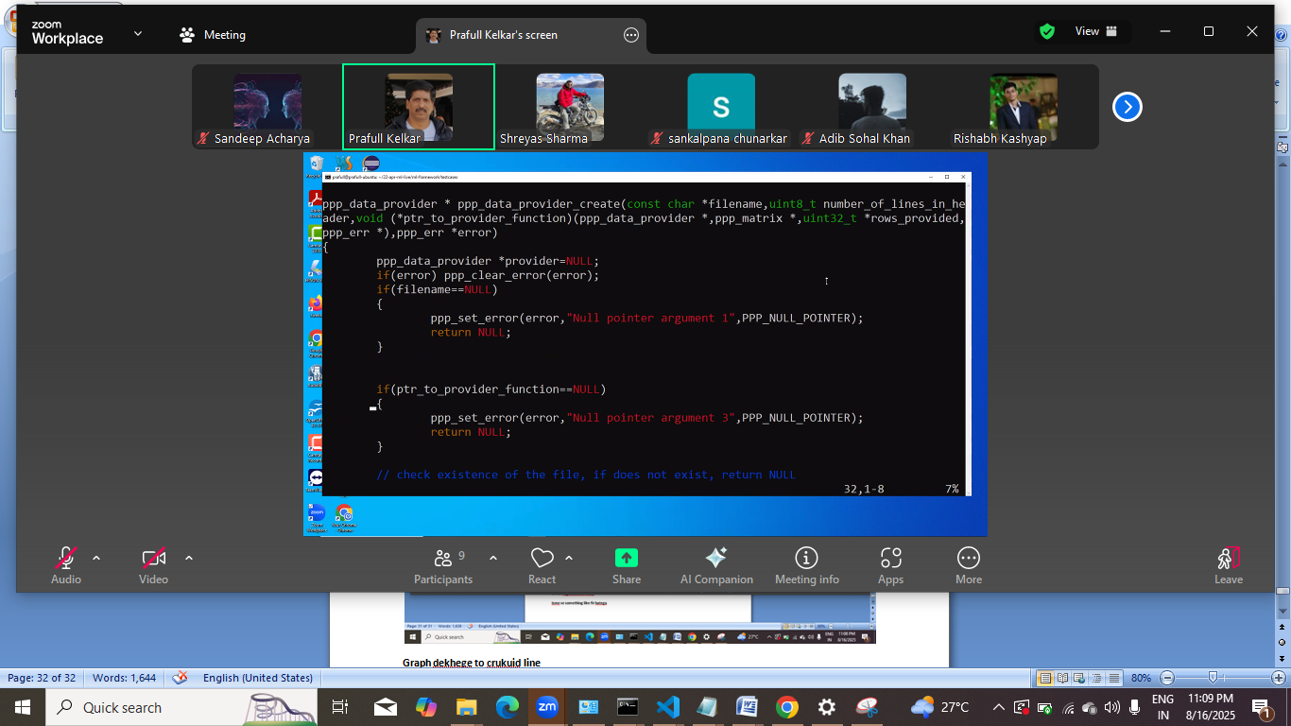
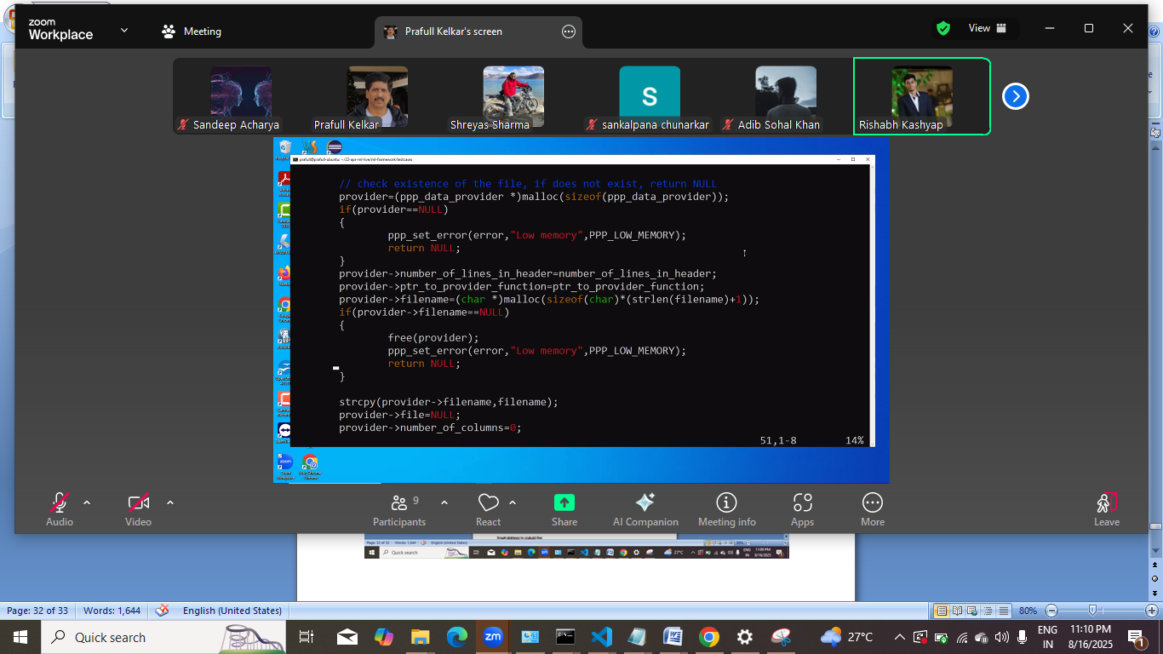
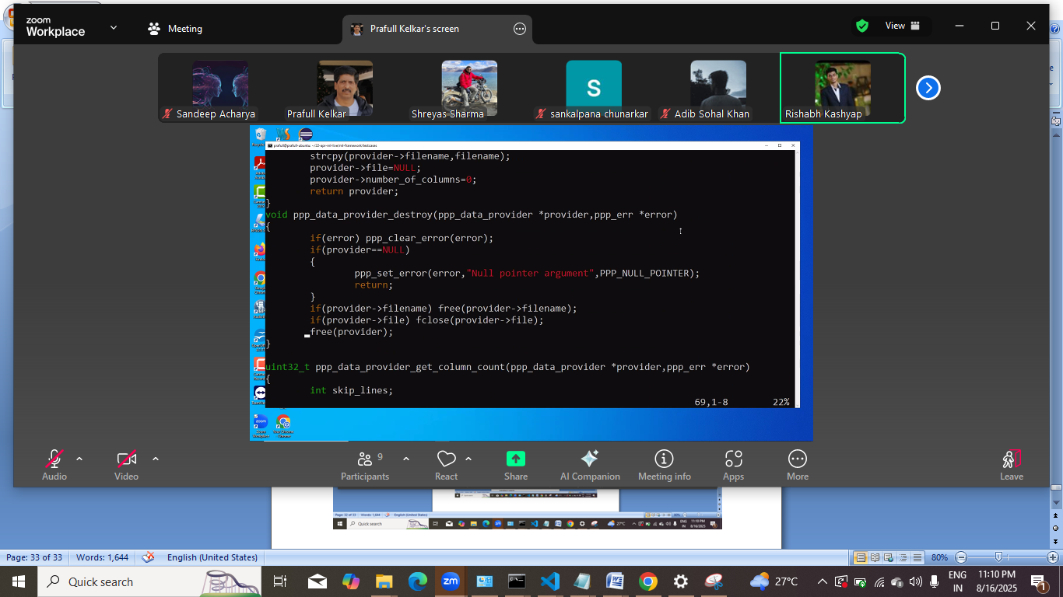
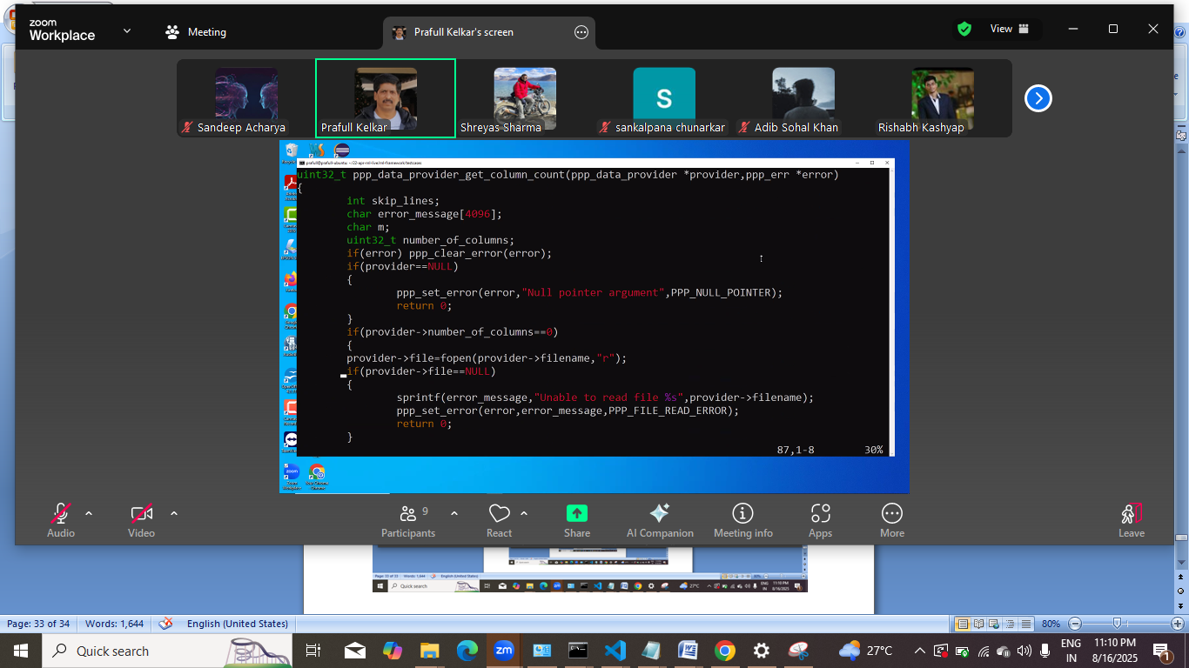
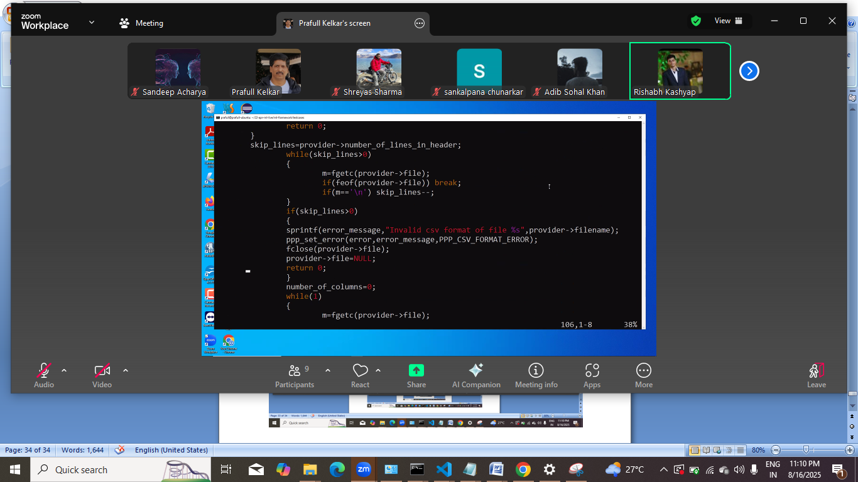
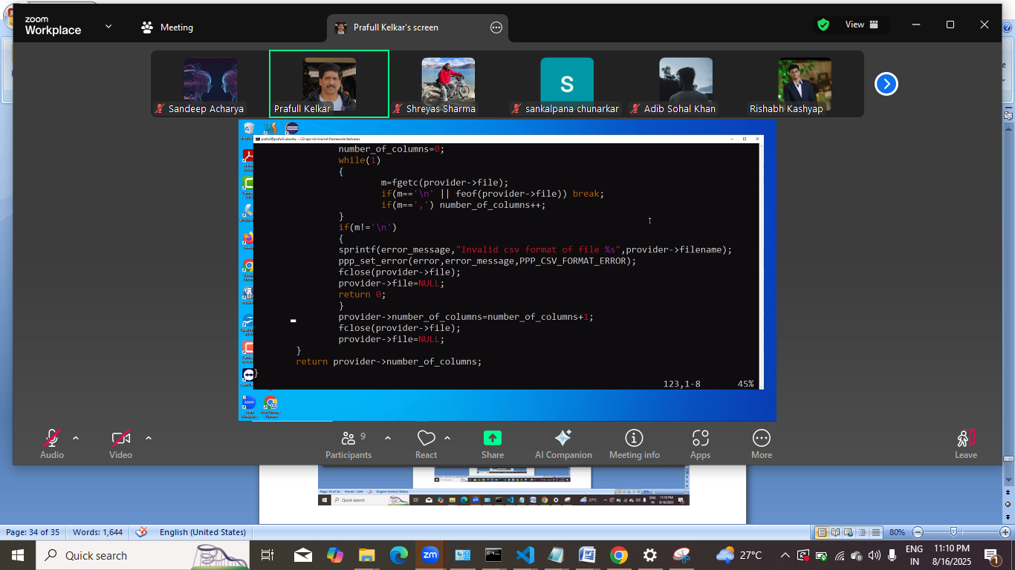
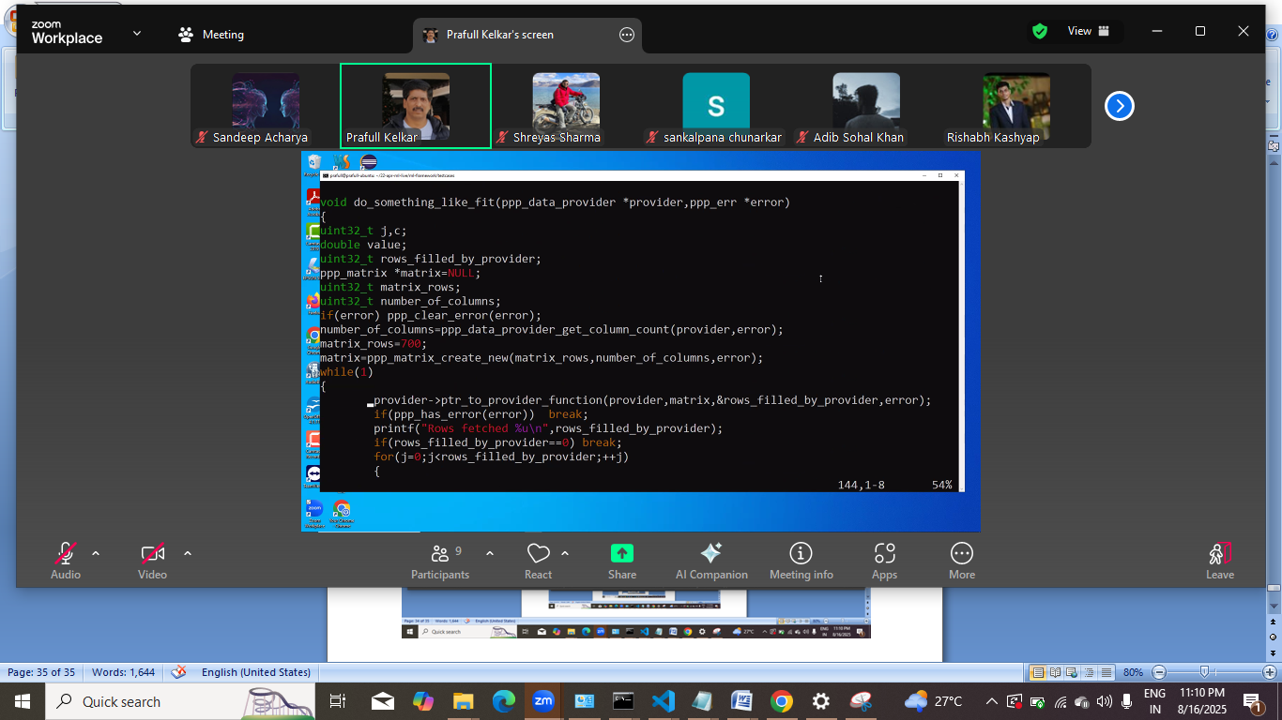
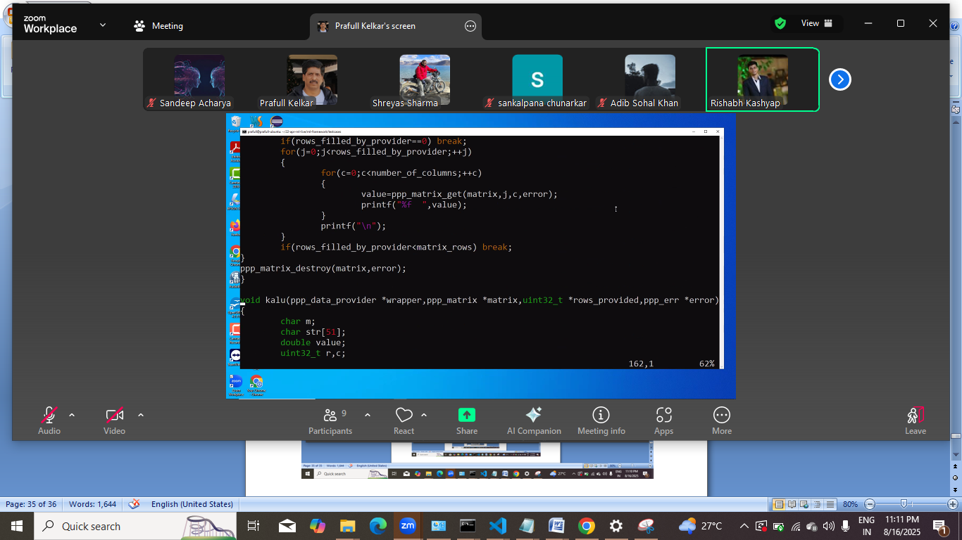
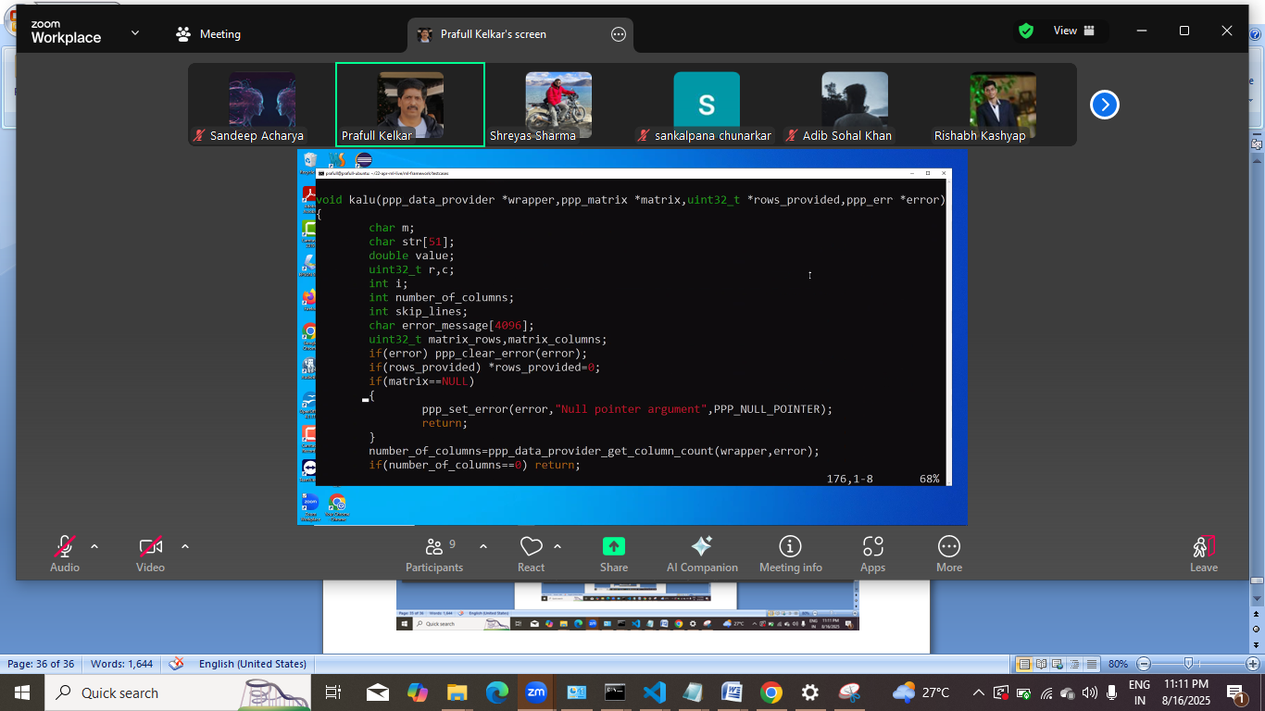
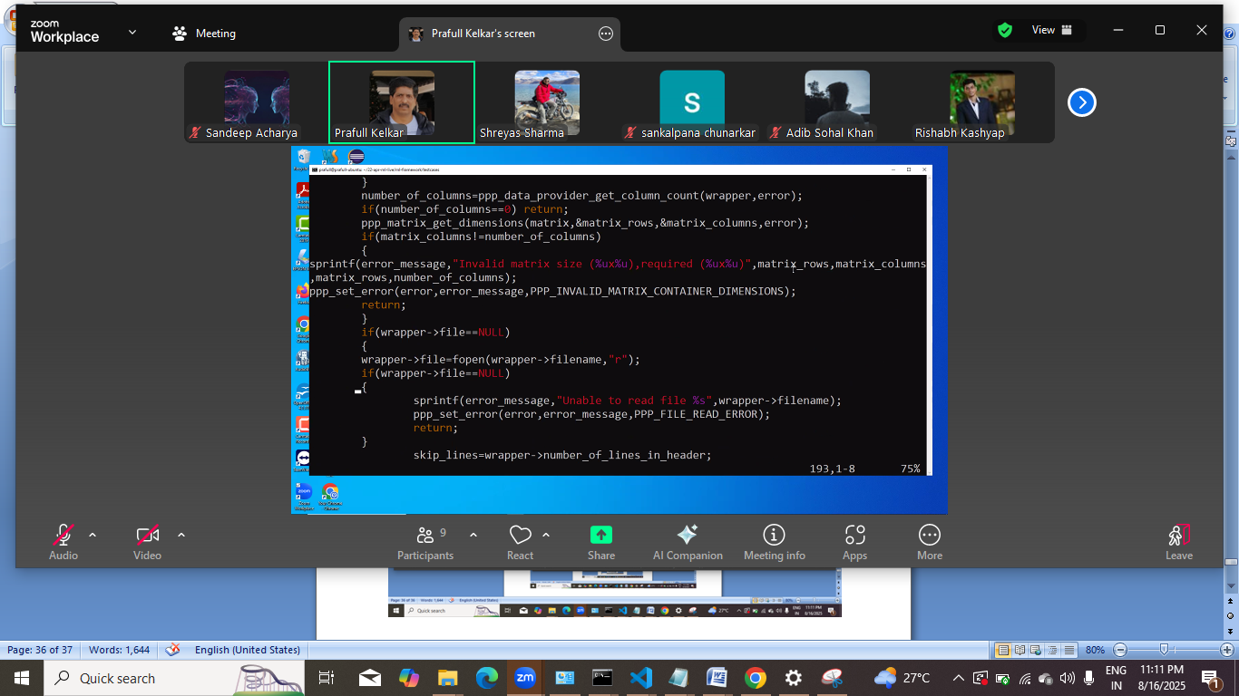
Stokastic amd
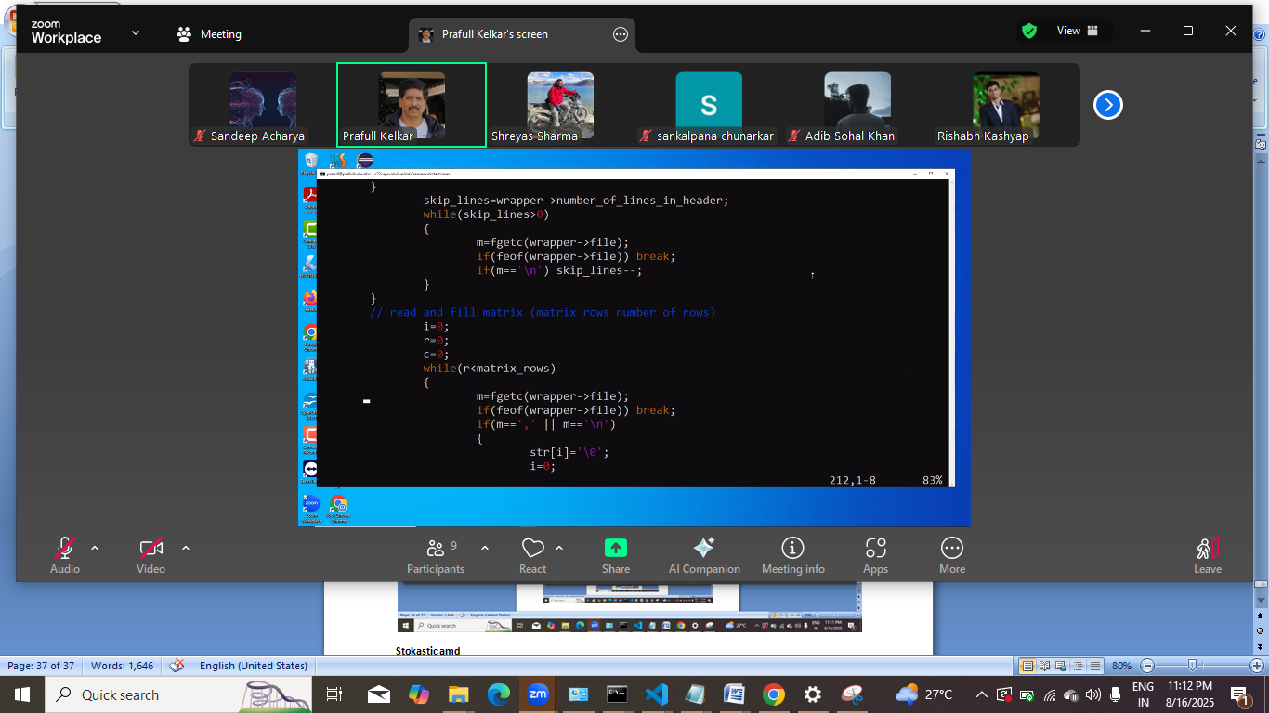
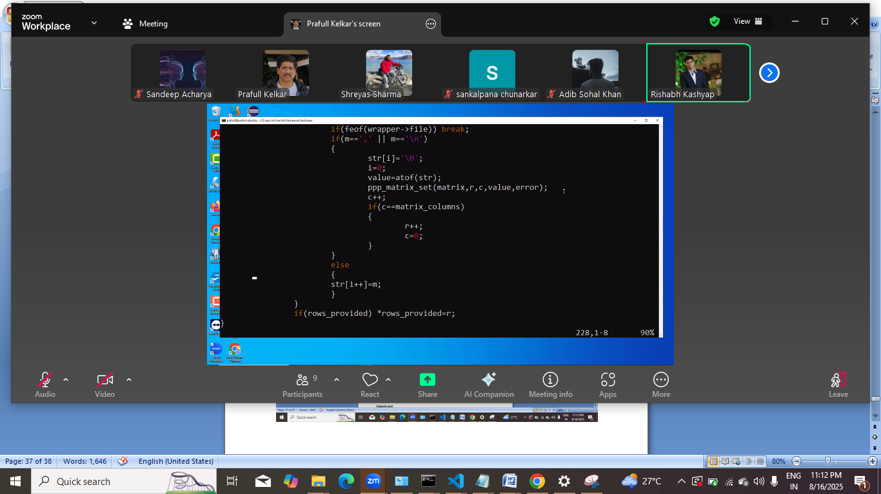

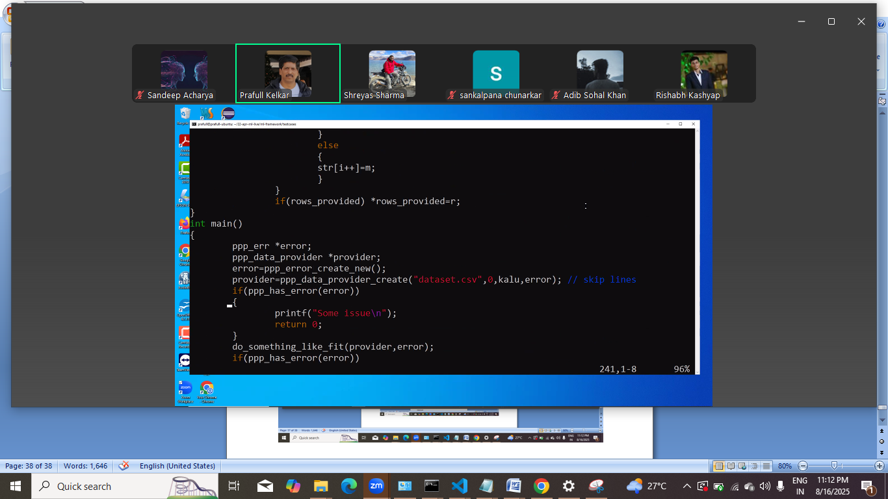
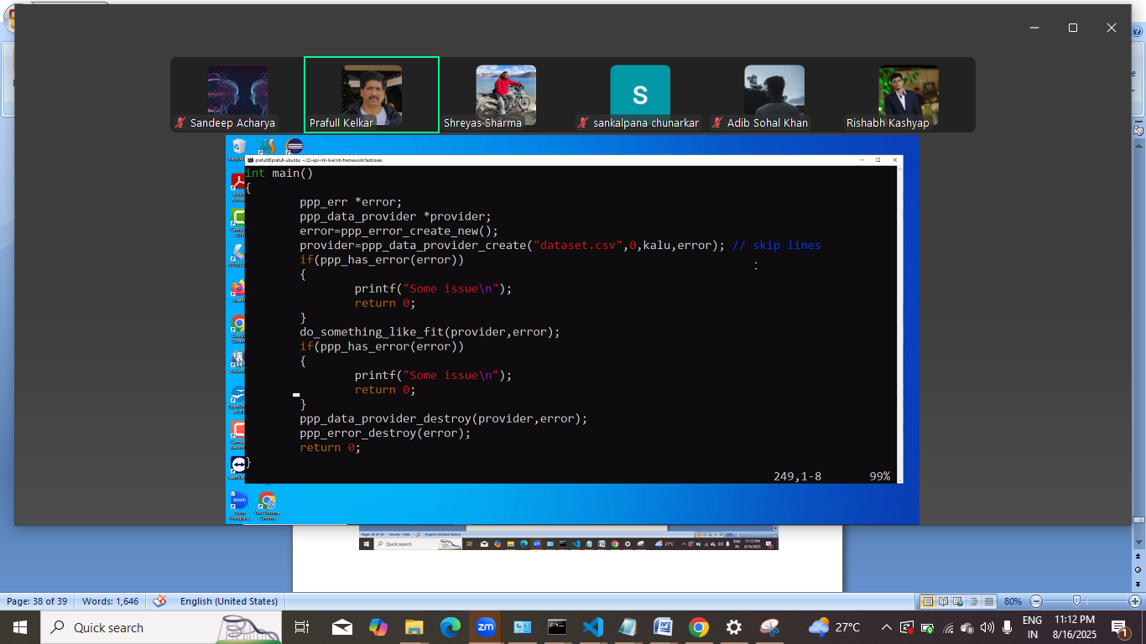
Stock , mini batch , scaling ki method
Next: polynomial regression pr kaam krna
Curve fitting
Data set generate
2 featrue wala bhi chlega
Jyada feature hoge to boll jesa bn jayega

Java pe 7 saal ka exp , but ai ml se dur rahe.
To company wale bolte he
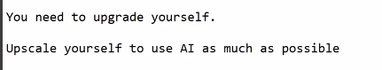
Jisne kuch dekha hi nahi ml ai but uske liye to weight term ho gaya.
End of the day unka mtlb he:
AI ko code base dena hota he.then vo uske andr ki function se related suggestion deta he.

Ide me plugin

Ab next:
To iske liye koi rasta khula he?
ML/AI ki team me ghus skte he kya?
Fresher level pr to certification ka koi mtlb nahi he.
Client ko chahiye ki programmer certified hona chahiye.

Online degree US, agar pesa and time he to ye explore krna chahiye
Ye esi planning he ki iska result 2 saal baad dikhega.
ML engineer resume me aane k liye degree ek option he online wali.

Ml ai ki team me bhi vahi model tuning.
Quant pr crazy money he. Isme c++ pr hi kaam krnapdta he.

Standford , cmu se degree.
